Date:18.02.2022

**Third Year B. Tech., Sem VI 2021-22**

**Advanced Database System Lab**

**Assignment submission**

**PRN No: 2019BTECS00064**

**Full name: Kunal Santosh Kadam**

**Batch: T2**

**Assignment: 6**

**Title of assignment: Performance Tuning for Assignment No. 4 & 5**

Do the performance tuning for Assignment No.4 & 5.

Hints:

1. Use the standard performance metrics and tabulate the results
2. Use any open-source tools / Oracle Explain Plan etc.
3. Prepare the benchmark report

Ans:

**Title:**

Performance Tuning

**Objective:**

Perform performance tuning for Assignment No. 4 &5

**Introduction & Theory:**

* Database performance tuning is a broad term referring to the ways database administrators can ensure databases are running as efficiently as possible.
* DBMS tuning typically refers to tuning queries for popular database management systems like MySQL or Oracle.
* Database tuning helps re-optimize a database system from top to bottom, from software to hardware, to improve overall performance.
* The Oracle Server is a sophisticated and highly tuneable software product. Its flexibility allows you to make small adjustments that affect database performance.
* By tuning your system, you can tailor its performance to best meet your needs.

**Procedure / Experiment:**

**Indices**

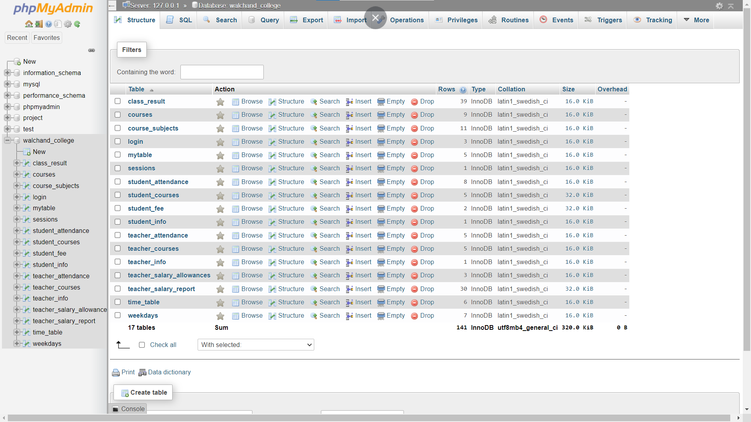

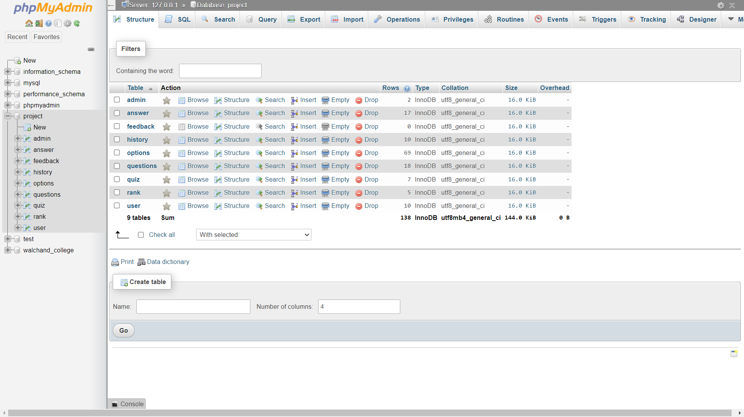

**Benchmark Report – Jmeter**

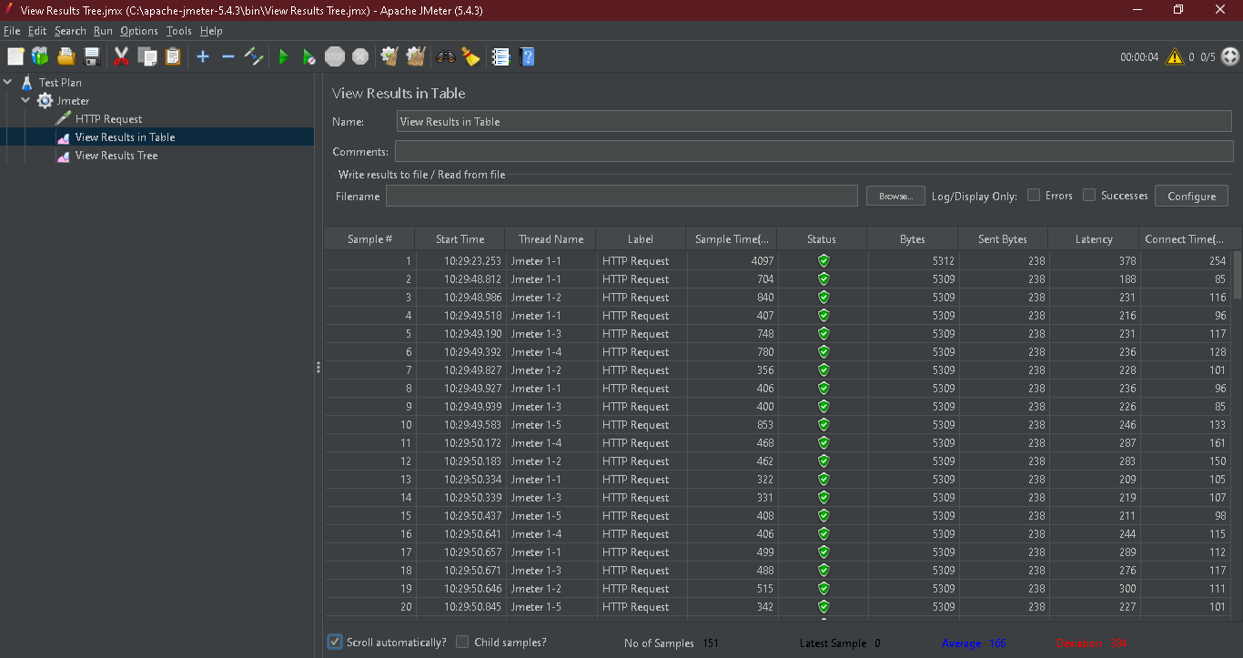



**Conclusion:**

Performed performance tuning for Assignment No. 4 & 5

**Reference:**

<https://en.wikipedia.org/wiki/Performance_tuning>